**High Tunnel Controller Manual Overrides**

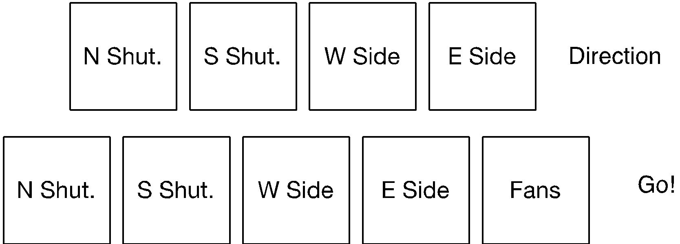

Default direction states: shutters, opening; sides, closing.

To open shutters, press their go relays (bottom row). To close shutters, hold down their direction relays (top row) while pressing their go relays. The return springs should hold the shutters in their last set position.

To close sides, press their go relays (bottom row). To open sides, hold down their direction relays (top row) while pressing their go relays.

The fans can only be turned on momentarily by manually overriding their go relay, but this is useful for testing them.

**WARNING:** There are no limit controls or safety devices to stop the sides when they are engaged manually. Make certain that all people in the vicinity are clear, and that you stop the sides before they reach their upward or downward limit of travel.